Created 1 bucket for storing data
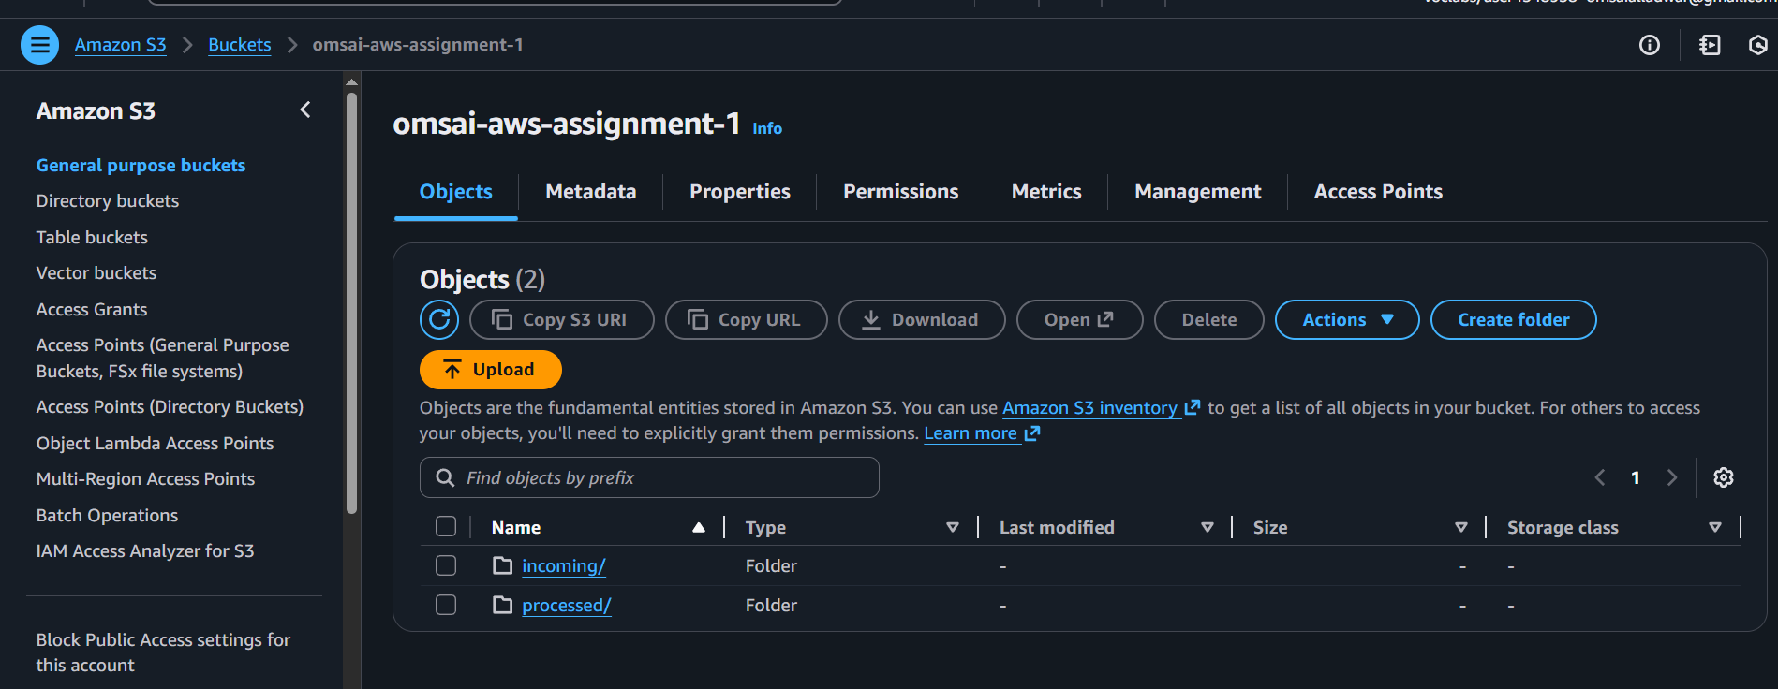
Added a lambda function
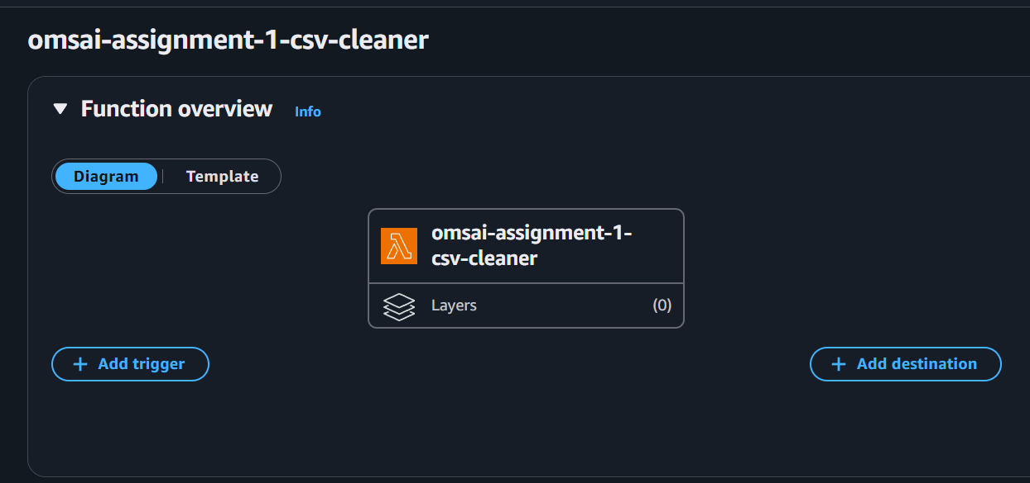

Code in aws cloud shell:
mkdir -p requests_layer/python
pip install requests -t requests_layer/python
cd requests_layer
zip -r ../requests-layer.zip .
cd ..
ls -lh requests-layer.zip

downloaded the file

ceated a layer uploading the zip file
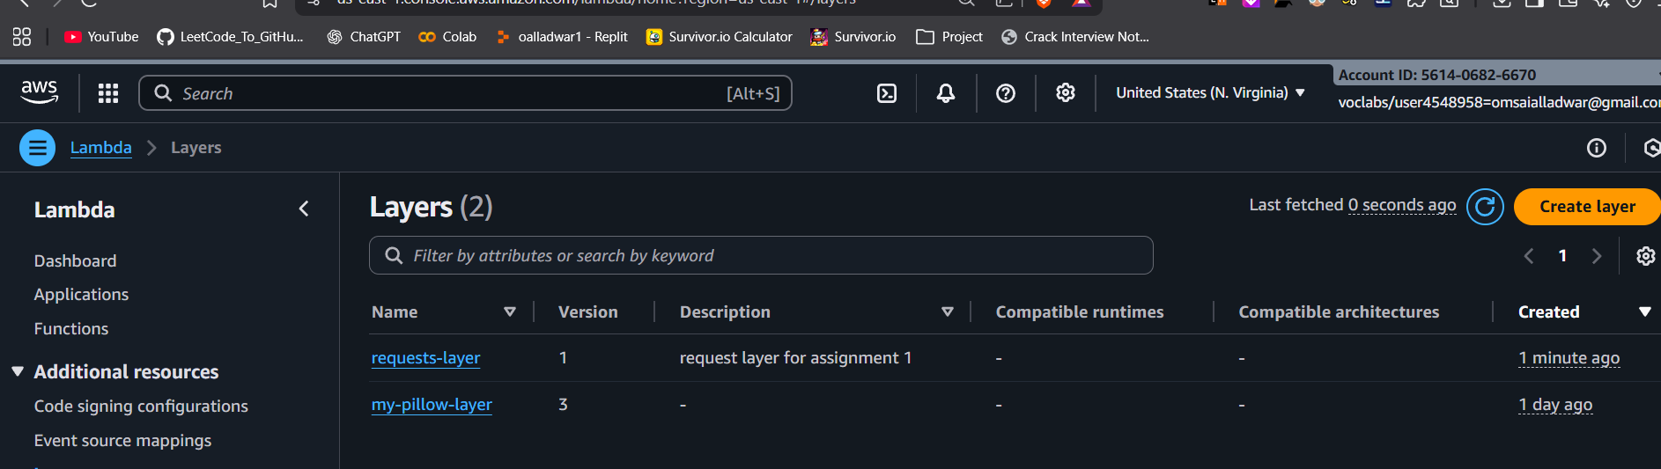

Attached layer to lambda function

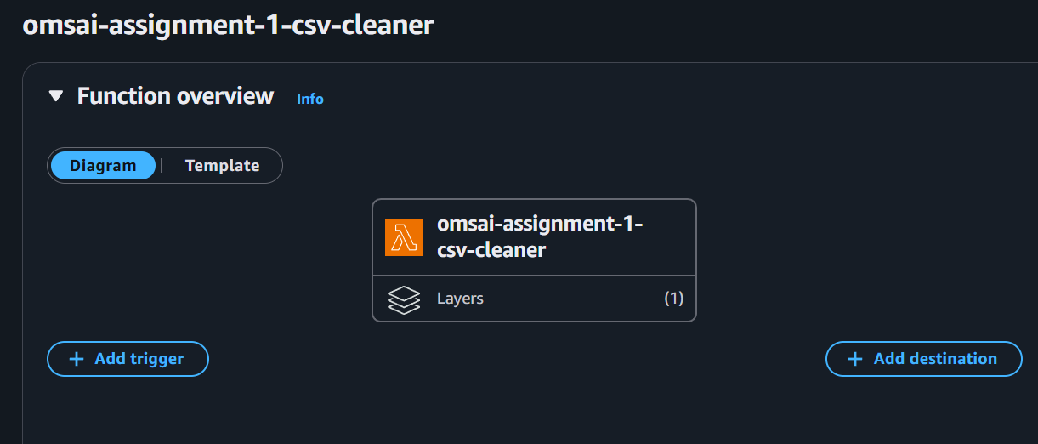

Changed the code of lambda function
import os
import csv
import io
import re
import json
import boto3
import requests

s3 = boto3.client("s3")
EMAIL_RE = re.compile(r"[^@]+@[^@]+\.[^@]+")

def is_valid_email(email):
if not email:
return False
email = email.strip()
return EMAIL_RE.fullmatch(email) is not None

def lambda_handler(event, context):
# event from S3 PUT
rec = event['Records'][0]
bucket = rec['s3']['bucket']['name']
key = rec['s3']['object']['key']

if not key.endswith('.csv'):
return {"status": "ignored", "reason": "not a CSV"}

# Download file
resp = s3.get_object(Bucket=bucket, Key=key)
body = resp['Body'].read().decode("utf-8")

reader = csv.DictReader(io.StringIO(body))

out_rows = []
invalid = 0

for row in reader:
# strip spaces
row = {k: (v.strip() if isinstance(v, str) else v) for k, v in row.items()}

# validate email
if not is_valid_email(row.get("email", "")):
invalid += 1
continue

# normalize city
if row.get("city"):
row["city"] = row["city"].title()

out_rows.append(row)

# Write processed CSV
out_key = key.replace("incoming/", "processed/")

if out_rows:
buf = io.StringIO()
writer = csv.DictWriter(buf, fieldnames=out_rows[0].keys())
writer.writeheader()
writer.writerows(out_rows)

s3.put_object(
Bucket=bucket,
Key=out_key,
Body=buf.getvalue().encode("utf-8")
)

summary = {
"input_file": key,
"output_file": out_key if out_rows else None,
"rows_in": sum(1 for _ in csv.DictReader(io.StringIO(body))),
"rows_out": len(out_rows),
"invalid_emails": invalid
}

try:
requests.post("https://httpbin.org/post", json=summary, timeout=5)
except Exception as e:
print("requests failed:", e)

return {"status": "done", "summary": summary}

added trigger to s3 bucket, event notification, of name incoming-trigger and event type is all object create event, and chose the lambda function omsai-assignment-1-csv-cleaner

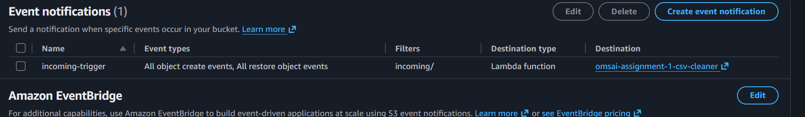

Added customers.csv file to the bucket into incoming folder
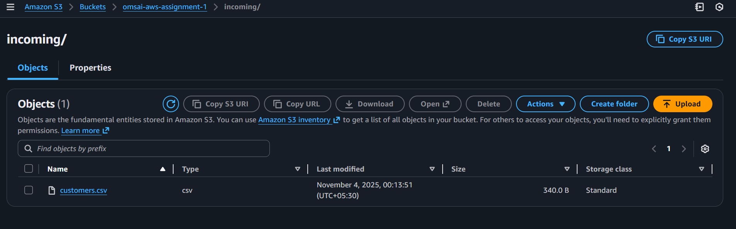

File processed and kept into processed folder
